Maciej Mączka, 2012-10-08
Gravity model use
A gravity model in transport economics predicts origin-destination flows based, in its simplest form, on the economic sizes of and distance between two units. The exogenous variables are weighted by a set of parameters (beta₀, beta₁, …, beta_{n}) and are ordered in a non-linear form on the right side of the model matrix equation. The left side of the equation is represented by a vector of the endogenous variable (airfreight).
For the purpose of Baltic Air Cargo Net project, the BP3 team of CNT develops an econometric gravity model. The BSR air cargo potential will be described by finding a mathematical relation between origin-destination vector of air cargo flows and a corresponding matrix of explanatory variables. The attractors and obstacles of the Baltic Sea Region (BSR) air cargo model are economic and geographic values defined by airport location and its catchment area. The search for the adequate data has been successfully completed during late August and first weeks of September 2012. EUROSTAT and World Bank data level of details allows for identification of annual origin-destination air freight among BSR and World nodes.
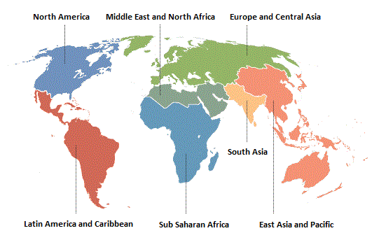  EDDH  EDDT/EDDB  EKCH  EPKT  EPWA  EPGD  BSR | 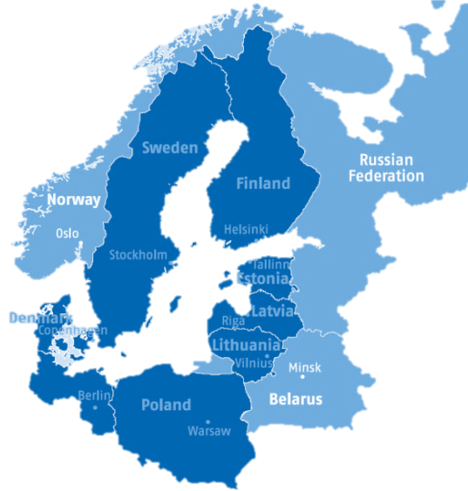  EYKA  EVRA  EETN  ESSA  EFHK  Non-Baltic  Germany
7 continent aggregated nodes () and the BSR aggregate ()  aligned to World Bank data continent aggregates | Current BSR model (2012-09-27) nodes:  11 airports ()and 4 country aggregates ( )
The current level of model aggregation includes 18 nodes:
- 6 complete continent aggregates (EAS, LAC, MEA, NAC, SAS, SSF)
- 1 incomplete continent aggregate (ECS)
- 3 complete country aggregates (BY, NO, RU)
- 1 incomplete country aggregate (Non-Baltic Germany according to eu.baltic.net)
- 11 BSR airports (Berlin Brandenburg System, Hamburg, Copenhagen, Gdańsk, Katowice, Warsaw, Stockholm, Helsinki, Tallin, Ryga, Kaunas)
- 1 BSR aggregate (the rest of BSR airports)
World Bank airfreight data gives a long term overview, but does not provide the disaggregation level required by model assumptions.
World | Baltic Sea Region Countries
WORLD BANK: the volume of freight [1000s of million ton-km], express, and diplomatic bags carried on each flight stage (operation of an aircraft from takeoff to its next landing)

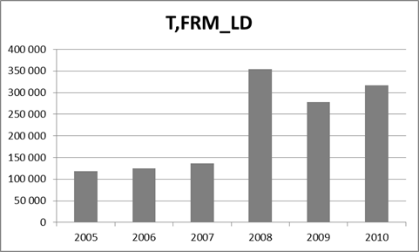  lack of DK and SE reports | 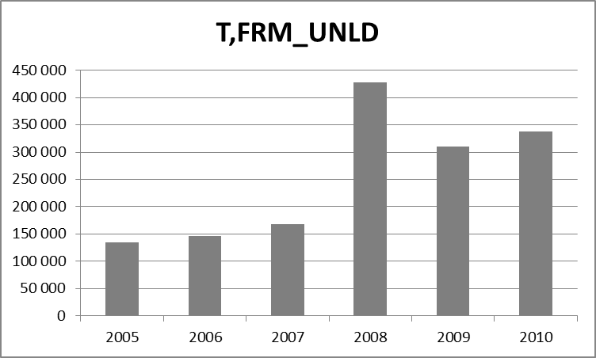  lack of DK and SE reports
Airfreight loaded in Baltic Sea Region in tons, EUROSTAT [avia_gor], reported August 2012 | Airfreight unloaded in Baltic Sea Region in tons, EUROSTAT [avia_gor], reported August 2012
EUROSTAT airfreight origin-destination data set (avia_gor) is satisfactory and thus it was chosen.

The disaggregation level of the EUROSTAT data allows for identification of annual (and even monthly) origin-destination aircargo flows. The annual data was chosen to build the chart. The permutation of origin-destination relations was limited to the BSR airports. The rest of the nodes is considered in the relation to the BSR airports and the BSR aggregate only. (see above maps)

UNLOADED [T,FRM_UNLD]

LOADED
[T,FRM_LD]
FLOW DIRECTION
LOADED
max (LOADED; UNLOADED)
UNLOADED
Considered origin-destination airfreight flows (sourced by EUROSTAT data)

Reliability of EUROSTAT data inclined, instead of using one set only, to choose form two data sets (T,FRM_LD and T,FRM_LD). The blue-colored cells of the BSR origin-destination matrix were filled with whichever annual value was greater. The other cells (purple and orange) were filled either with loaded or unloaded airfreight flow value. Known issues like e.g. lack of reports of Sweden and Denmark for 2005, 2006 and 2007, limit the possibility to enrich the model with preceding years. Airfreight of 2011 was only partly reported and there are no records of 2012.

Each of the BSR nodes catchment area is a cumulative value of NUTS-3 economy and population values (a mathematical method of choice is under construction). The centre-points of nodes were located in places considered as most important source of demand for air cargo service (usually at a midpoint between two largest airports). Each centre-point is represented by geographical coordinates.

The parameters (betas) estimation will be done using Ordinary Least Square estimator applied to the log-linear model.
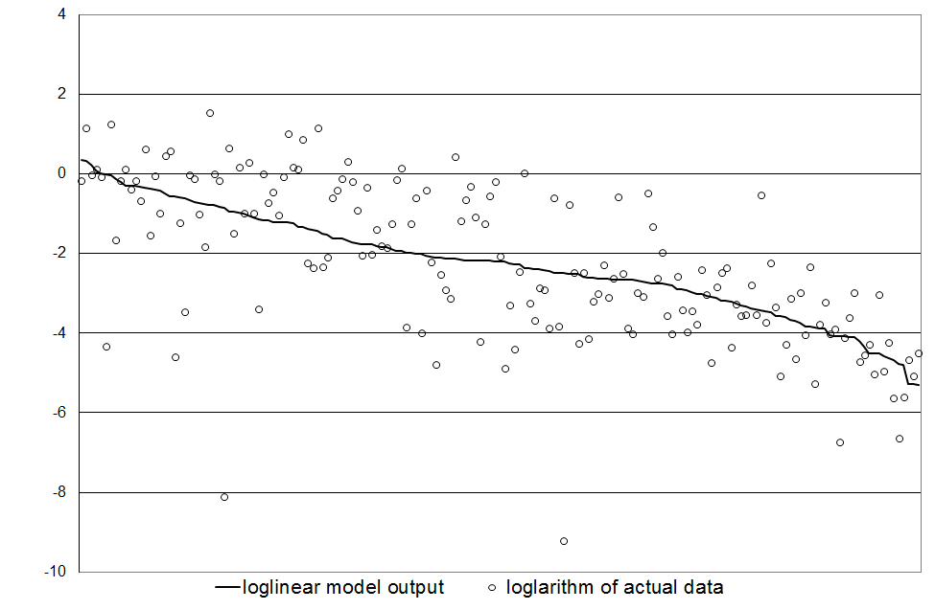
The forecast will be done by linear extrapolation of time series of annual data of endogenous variables. The standard deviation forecast of the scenarios for the medium term forecast (>3 years). Forecast ex-post is done for model validation and covers year 2009 and 2010. The forecast ex-ante goes beyond known data.
Example – forecasted airfreight flow from Warsaw to Kaunas
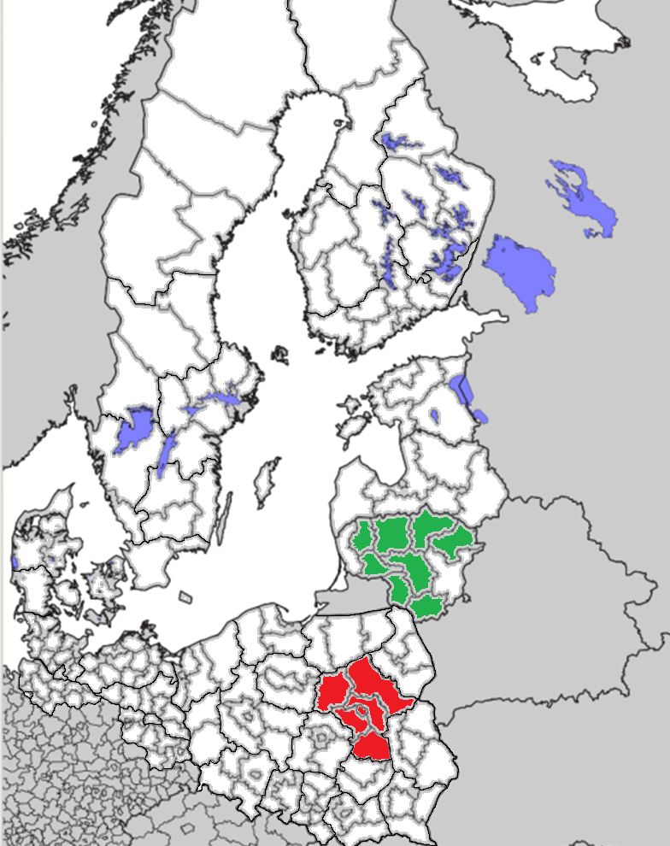
Arbitrarily chosen EPWA catchment area |  | Linear trend example of “catched” GDP at EPWA
Actual data:  2008: 531 ton  2011: ??? ton  2014: ??? ton | Example of model output (reasonable scenario):  200 ton (${AIRFREIGHT}_{2008}=0,02$)400 ton (${AIRFREIGHT}_{2011}=0,04)$  400 ton (${AIRFREIGHT}_{2014}=0,04)$
lack of DK and SE reports
Method test and preliminary calculation for the a total of Baltic Sea Region airfreight

Observed issues:
- Undesirable high correlation between exogenous variables (tariffs and gdp of destination, tariffs and population of destination, tariffs and distance)
- Problem with zero values in log-linearization of model
- Uncertain air cargo – distance relation, several signals of positive correlation
- Performance of model – level of disaggregation trade off
- Unrealistic linear trend forecast of GDP (differences in EUROSTAT and local statistical reports concerning GDP of 2009)

The theory of gravity was applied to human interaction for a first time in the 19th Century. (http://ntl.bts.gov/DOCS/CAT.html, p. II-1)
explained by the econometric model
chosen to match the World Bank data

